Concentrations, loads, and associated trends of nutrients entering the Sacramento-San Joaquin Delta, California

### By Dina Saleh and Joseph Domagalski

# ABSTRACT

# INTODUCTION

The Sacramento-San Joaquin Delta (hereafter referred to as the Delta) is part of the largest estuary on the west coast of North America covering an area of about 2,984 km2. The Delta is also a point of transfer of freshwater to cities and agricultural regions (Templin and Cherry, 1997, Saleh and Domagalski, 2015). About 2,024 km2 of the Delta is agricultural land and home to 230 species of bird, 45 species of mammals, and 52 species of fish (Saleh et al., 2003; CA.Gov Delta Protection Commission, <http://www.delta.ca.gov/rec_economic.htm>). About two thirds of the drainage of the freshwater drainage from California (Sacramento and San Joaquin and other rivers) enters the Delta, and numerous management decisions need to be made, almost daily, regarding diversions, water quality, aquatic species management, and environmental flows (Luoma et al., 2015).

In recent years, the forms of nutrients or nutrient stoichiometry, especially the relative amounts of ammonium relative to nitrate from wastewater effluents, have been suggested as causing changes in primary productivity and/or changes in the types of algae, which may affect food webs, in the Delta (Glibert, 2010, Parker, et al., 2012). The potential effects on the ecosystem from ammonium in wastewater discharge prompted the California Central Valley Water Quality Control Board to issue new discharge requirements for one of the largest dischargers of wastewater to the Delta, the Sacramento County Regional Sanitation District, hereafter referred to as Regional San (<https://www.regionalsan.com/echowater-project>). Mandated upgrades to the Regional San facility include biological nutrient removal which will remove essentially all the ammonium, and most of the nitrate. In addition, there will be chemical phosphorus removal with tertiary clarification, tertiary filtration and ultraviolet (UV) disinfection (Yost 2011). These upgrades are expected to significantly decrease nutrients load to the Delta to about 99% annual decrease in ammonium, and 75% annual decrease in Total Nitrogen (TN) concentrations (Krich_Briton, A,2017 memo). The treatment plant upgrades will result in a substantial decrease in the amount of nitrogen entering the Delta and may in itself result in ecosystem changes (<https://www.regionalsan.com/echowater-project>).Other treatment plants that discharge to the Delta waters are also upgrading their facilities or management of their effluents. These include the Modesto Water Quality Control facility, the Turlock Regional Water Quality Control facility and the Stockton Regional Wastewater Control facility (figure 1).

Once these upgrades are operational, there will be a change in the amount of inorganic nitrogen entering the Delta. Ongoing research is attempting to understand how these changes may affect the Delta ecosystem (Richey et al., 2018). To better understand the future effects of these planed changes on nutrient availability and transport to the Delta it is important to evaluate historical nutrient loads and trends in the Sacramento and San Joaquin Rivers upstream of these Delta facilities. A multi-year record of monitoring data is available for the various forms of nitrogen and phosphorus at two locations, the Sacramento River at Freeport and San Joaquin River near Vernalis (figure 1). Data are available for the 1970 to 2019 period. Data from these two sites will be used to evaluate historical nutrients specific sources, spatial distribution, and transport of nutrients to the Delta from the upstream portion of the two watersheds. The long-term record of discrete data collection will be supplemented with a smaller record of high frequency monitoring for nitrate at the Sacramento River at Freeport site. High frequency monitoring is accomplished with a sensor placed in the river that collects a measurement at 15-minute intervals. The longer record of discrete sampling captures various weather conditions including wet years (1997) and drought years (2012-2016). Trend estimation was completed for Kjeldahl nitrogen, total nitrogen (TN), nitrate (NO3), ammonium (NH4), orthophosphate (OP) and total phosphorus (TP) allowing managers to understand the watershed contribution of various forms of bioavailable nutrients, as these enter the Delta and provide the nutrients for aquatic food webs.

Nutrient trends in the estuary and inflow streams to the Delta have been reported on by Beck et al, 2018, and Schlegel and Domagalski, 2015. Beck et al., 2018 discussed trends in nitrate, ammonium and silica at the two sites of this study and within the estuary up to the time period of 2013. Schlegel and Domagalski,2015 also discussed trends up to 2013 for total nitrogen, ammonium, nitrate, and total phosphorus for the two sites of this study and for upstream sites in both the Sacramento and San Joaquin Rivers. This study expands on the previous investigations by extending the study period to 2019, by including the previously modeled nutrients and bioavailable orthophosphate, and an examination of watershed sources of total nitrogen and total phosphorus.

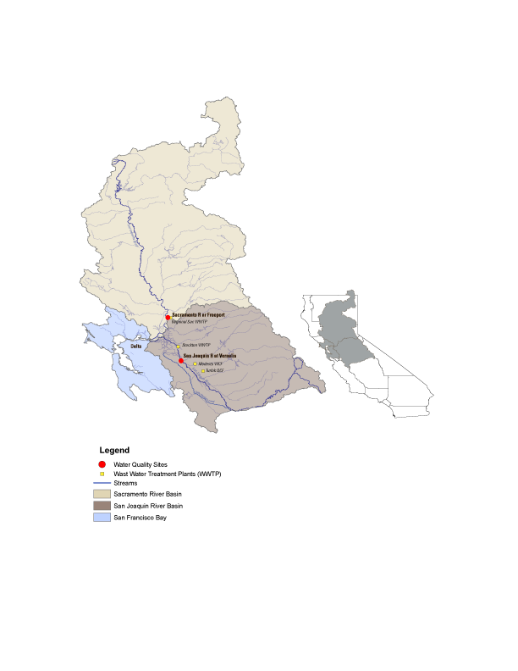

Figure 1. Location of sampling sites, geographic extent of the Sacramento and San Joaquin River watersheds and locations of selected wastewater treatment plants

# **Study area and Data Sources**

The Delta system is the largest estuary on the west coast of North America consisting of about 4,160 km2 of which the Delta makes up about 2,984 km2.The Sacramento and San Joaquin Rivers deliver freshwater to the Delta with about 84% coming from the Sacramento River, 13% coming from the San Joaquin River, and 3% from other smaller rivers (Jassby and Cloern, 2000, Saleh and Domagalski, 2015). The Sacramento and San Joaquin Rivers are the two largest rivers in California delivering an average of 650 m3/s and 120 m3/s of water respectfully to the Delta annually. Both river systems contain many upstream diversions and impoundments designed to provide flood protection, drinking water, and irrigation water for agricultural areas within the Central Valley (Kratzer at al, 2011). Nutrients enter the Delta primarily through the Sacramento and San Joaquin Rivers and from municipal wastewater treatment plant (WWTP) inputs. The Sacramento Regional Wastewater Treatment Plant is located about 0.5 river kilometers downstream from the Sacramento River at Freeport site (figure 1). However, the discharge point for the Sacramento Regional Wastewater Treatment Plant is about 0.18 km downstream from the monitoring site at Freeport (Kraus et al, 2017). The treatment plant collects wastewater from approximately 1.4 million customers and was designed to release about 116 Million Gallons per Day (MGD) of secondary treated effluent to the Sacramento River, with nutrient loadings averaging about 13,594 kg/ day of Ammonium, 14,818 kg/day Total Nitrogen (TN), and 999 kg/day Total Phosphorus (TP) (Yost, 2011). The Stockton WWTP is located about 40 river kilometers downstream from the Vernalis site. Stockton WWTP was designed to release about 23 MGD of tertiary treated with nitrification effluent to the San Joaquin River, with lower nutrient concentrations averaging about 114 kg/ day ammonium, 1,579 kg/day Total Nitrogen (TN), and 89.9 kg/day Total Phosphorus (TP) (Yost, 2011).

Concentration data for nitrate, ammonium, Kjeldahl Nitrogen, orthophosphate, total phosphorus, and total nitrogen (total nitrogen is the sum of nitrate and Kjeldahl Nitrogen) for the study were obtained from various sampling programs at two USGS stream gauge locations, Sacramento River at Freeport (11447650) and the San Joaquin River near Vernalis (11303500) over the 1970-2019 period. All the discharge data and most of the water quality data were obtained from U.S. Geological Survey National Water Inventory System (NWIS) other additional water quality data were obtained from previously reports Kratzer et al., 2011. These two sites selected for this study were sampled frequently (have more than 200 samples) over the 1970-2019 period and have a continuance record of streamflow data concurrent with the water quality records at these sites.

# **Methods**

Discharge measurement methods are given by Turnipseed and Sauer, 2010, and Sauer and Turnipseed, 2010. Measurements of stream stage are collected every 15 minutes, and then converted to discharge using rating curves. Instantaneous measurements are collected periodically to verify the rating curves. Nutrients were analyzed at the U.S. Geological Survey laboratory as described by Fishman, et. al., 1993. The period of record was for this analysis was 1970 to 2019. Two methods were used to either estimate nutrient concentrations, mass loads and trends, and for assessing watershed sources. Concentrations, mass loads, and trends were estimated using the Weighted Regressions on Time, Discharge, and Season (WRTDS) model (Hirsch et al. 2010). Watershed sources of nutrients (total Nitrogen and total Phosphorus) were assessed using the SPAtially Referenced Regressions On Watershed attributes (SPARROW) models (Preston et al., 2009, 2011b).

The WRTDS model is written in the R computing framework and is publicly available from the Comprehensive R Archive Network (<https://www.R-project.org>). The model was developed to produce estimates of concentration and flux, along with the ability to calculate flow-normalized estimates of concentration and flux, with graphical capabilities to illustrate the resulting trends. Estimated concentrations and fluxes for nitrogen forms; Nitrate (NO3), Ammonium (NH4), Total Kjeldahl Nitrogen (TKN), Orthophosphate (OP), and Total Phosphorus (TP), over the 1970-2019 period were estimated using the WRTDS model for the Sacramento River at Freeport and the San Joaquin River near Vernalis. WRTDS evaluates a concentration-discharge relationship based on time, discharge and season by re-evaluating coefficients for each day of estimation. The estimated concentration is a product of the following equation:

In(*Cij*)=*β0*+ *β1Tij* + *β2* In(*Qij*)+ *β*3 sin(2π*Tij*) + *β*4 cos(2π*Tij*) + ε*ij*  (1)

Where for a specific day *i* and year *j*:

*C*; is the concentration (in mg/L), *Q*; is the mean daily discharge (in m3/s), T; is the time in decimal years, β; are fitted coefficients, and ε is the unexplained variation (Hirsch et al. 2010). Statistical significance of the calculated loads is given by a flux bias statistic. Most of those indicated a favorable model with a bias statistic of plus or minus 1 to 10%. Estimates of concentration and load can be presented on a daily to annual time scale. Further information about how concentrations and loads change with time is provided by a flow normalization calculation. Within an annual time period, there are great variation in historical streamflow measurement at any given site over the period of the record, which may be natural, such as flood and drought cycles, or through water management. To deal with discharge variations the Flow-Normalized-Concentrations (FNC) approach is used in WRTDS (Hirsch et al. 2010). The FNC for day *i* and year *j* is defined as (equation2):

(2)

Where: C*ij* is the flow-normalized-concentration for day *i* and year *j*, g*ij*(Q) is the probability density function of discharge (Q) for day *i* of year *j*, and w(Q,Tij) is a smooth continuous function of two variables, discharge (Q) in m3/s, and time (T) value for day *i* and year *j*. WRTDS uses weighted regression approach to estimate *w*, g(Q) is estimated with the flow-normalization approach with the assumption that discharge is stationary for any day *i* in a year *j* over the period of record (Hirsch et al. 2010).

Trends in concentration or load, and their significance levels, were calculated using the EGRETci R-package. The EGRETci R-package uses a bootstrap method and an adaptive Bayesian approach to evaluate when to accept or reject the null hypotheses (Hirsch et al., 2015). An  value of 0.1 is used in order to increase the power to detect a real trend. A term, denoted as *f* , is the fraction of bootstrap replicates, in an infinite number of bootstrap replicates, for which the estimated change in flow normalized flux is positive. An estimate can be made at any stage of the bootstrap process denoted as ̂*f*. That term is defined as the mean of the Bayesian posterior distribution of *f*. A full description is given in Hirsch et al., 2015. Definitions for determining the statistical significance of a trend direction, given by the function of ̂, are given in Table 1. The EGRETci method applies a bootstrapping test using Monte Carlo simulations to estimate the probability of detecting a trend. The model runs 100 bootstrapping test iterations over a 200-day bootstrapping window for the 1970-2019 duration period. Output from the EGRETci test includes a p-value statistics, however trend uncertainty is expressed in terms of an estimate of trend likelihood representing the probability of increasing or decreasing of trends within 100 bootstrapping iterations (Hirsch et al. 2015). The trend likelihood terminology is divided into 3 categories (Table 1). Within any trend direction; a “Highly Likely” trend would mean that at there is at least 95 out of a 100 chance that there is a trend in that direction, a “Very Likely” trend means that there are 90 to 95 chances of a 100 that the trend would be in a specific direction, and finally a “Likely” trend would mean that there is a 90 to 66 chances of a 100 that there is a trend in a that direction. Along with the likelihood and the direction of trend for each constituent, EGRETci output will also provide an estimated change value for concentrations and loads in mg/l and kg/year respectively.

Table 1. Definitions for descriptive statements of trend likelihoods for WRTDS Bootstrap test as a function of ̂, the posterior mean estimate of the probability of an increasing trend (Hirsch et al., 2015).

|  |  |
| --- | --- |
| **Range of ̂ values** | **Descriptors** |
| ≥ 0.95 *and* ≤ 1.0 | Highly Likely |
| ≥ 0.9 *and* < 0.95 | Very Likely |
| ≥ 0.66 *and* <0.90 | Likely |
| > 0.33 *and* < 0.66 | About as Likely as Not |
| > 0.1 *and* ≤ 0.33 | Unlikely |
| > 0.05 *and* ≤ 0.1 | Very Unlikely |
| ≥ 0 *and* ≤ 0.05 | Highly Unlikely |

Trends in daily streamflow were completed using a non-parametric Mann Kendall approach using various R packages (<https://www.R-project.org>, <https://owi.usgs.gov/blog/Quantile-Kendall/>). Statistics were compiled for minimum day, median daily, maximum daily, and mean daily measurements. Statistical results were compiled across the range of non-exceedance probabilities.

The SPARROW model (Preston et al., 2009, 2011b) uses a hybrid statistical and process-based approach that relates nutrient loads to upstream sources, and watershed characteristics using a nonlinear least squares (NLLS) multiple regression. This was used to identify sources and estimate loads of total nitrogen and total phosphorus to the Sacramento and San Joaquin Rivers. SPARROW includes nonconservative transport, mass-balance constraints, and water flow paths referenced to the digital a stream network, National Hydrography Dataset Plus (NHD-Plus) Version 2 (http://www.horizon-systems.com/NHDPlus/NHDPlusV2_home.php), which defines topography, streams characteristics, and reservoirs inputs for the SPARROW model. Potential sources of nutrients to streams such as atmospheric deposition, fertilizer use, geologic sources, wastewater treatment, amounts of land in different use categories, and other potential variables were based on data for 2012. Discharge used to model the movement of total nitrogen and total phosphorus from sources to streams was almost normalized to 2012 by a de-trending procedure. The SPARROW model includes three types of parameters to provide a prediction on fluxes leaving catchments: sources, land-to-water delivery variables, and instream loss. Water-quality predictors in the model are developed as functions of both reach and land surface attributes and include quantities describing contaminant sources (point and nonpoint) as well as factors associated with rates of material transport through the watershed. Details on the theoretical development of the SPARROW model are provided by Alexander et al. (2008) and Schwarz et al. (2006).

High frequency nitrate concentrations were measured at the Sacramento River at Freeport site using automated submersible ultra-violet nitrate sensors (SUNA, Version 2; Satlantic, NS, Canada), which measures both nitrate and nitrite. Manufacturer stated precision for these 10 mm path length instruments is 0.3 mM (0.004mg N L21) and accuracy is 2 mM (0.028 mg N L21). Further details are given by Kraus et al., 2017. Nitrate concentrations measured with the sensor were compared with 100 discrete measurements collected at the same location. There was a good correlation between sensor and laboratory measurements (r2 = 0.94) and the sensor was biased slightly higher than the laboratory. Sensor results shown in this report were corrected using the regression equation obtained from the laboratory and sensor measurements.

# **Results**

## ***Streamflow Tends***

Statistical analyses were used to evaluate trends in daily discharge over the 1970-2019 period for the Sacramento River at Freeport and the San Joaquin River near Vernalis. There is a decreasing trend in all four annual statistics (minimum daily, median daily, maximum daily, and mean daily) for both sites (figure 2, and figure 3). However, these trends are only statistically significant for annual minimum daily discharges at the Sacramento River at Freeport with a p-value of 0.052 and a decreasing slope of 0.76% per year. This is also reflected in the Quantile-Kendall plot (figure 4). The plot shows that at both sites and over the 365 days of the year, there is no statistically significant trend in all parts of the flow duration curve (Hirsch, 2015).

Discharge measurements at the Sacramento River at Freeport and the San Joaquin River near Vernalis varies significantly and are consistent with variable weather condition during the 1970-2019 period. During a high-water year, such as 1997, maximum discharge measurement at the Sacramento River at Freeport and the San Joaquin River near Vernalis reach to 3200 m3/sec, and 1537 m3/sec respectively. Discharges are much lower in drought years, such as 2012-2016 (Western Regional Climate Center <http://www.wrcc.dri.edu/cg-bin/cliMONtpre.pl?ca7630>) where average measured mean daily discharge at the two sites were about 175 m3/s at Sacramento River at Freeport, and about 9 m3/sec at San Joaquin river near Vernalis.

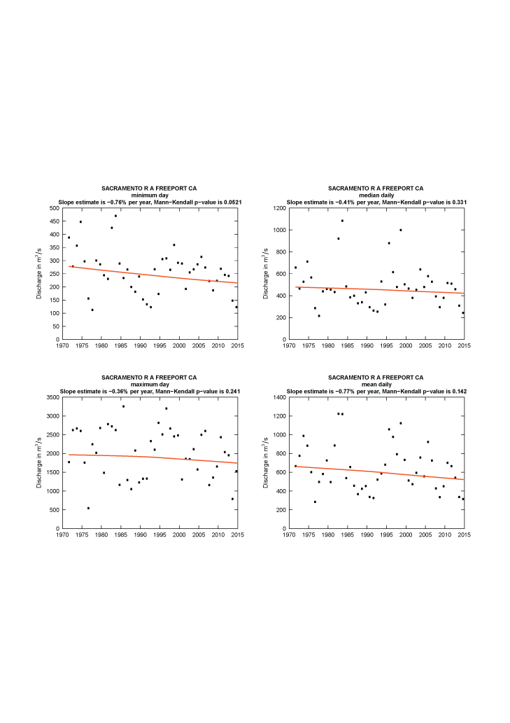

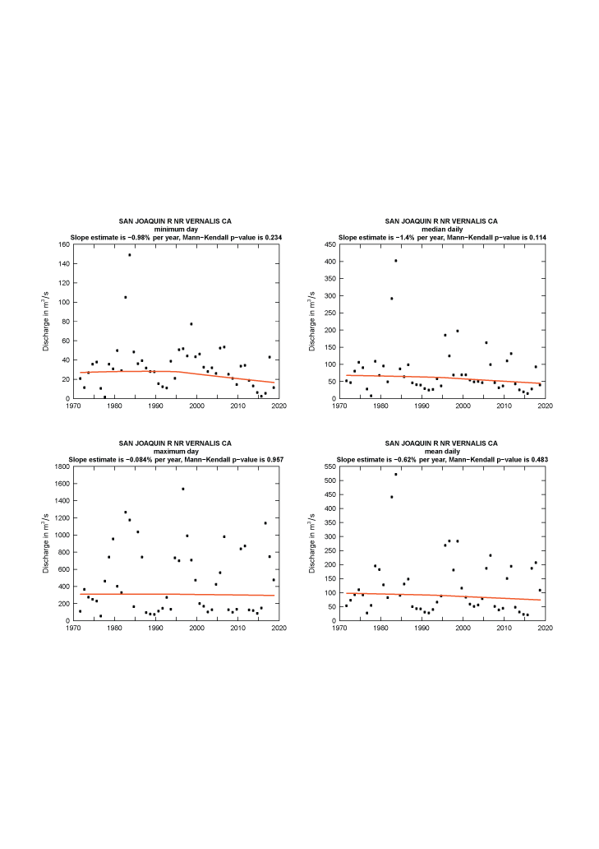

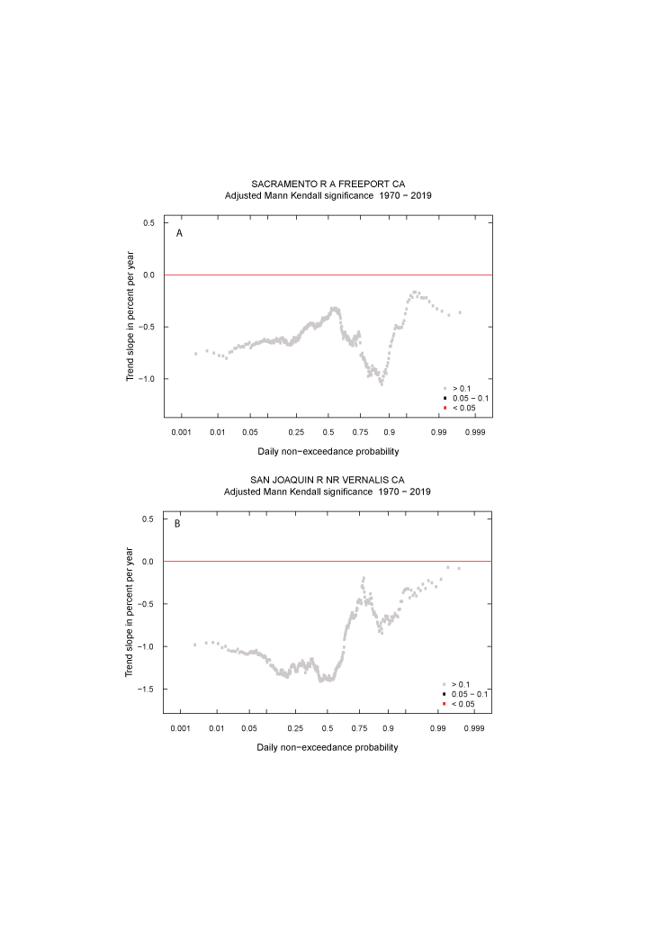

## ***Sacramento River at Freeport, Nutrient Concentrations, Fluxes, and Trends***

Output of the WRTDS model for the Sacramento River at Freeport site are shown in figure 9. Flow-normalized nitrate concentrations and loads follow a similar pattern throughout the 1970-2019 period (fig 9a, and 9b). Concentrations and loads increase in the earlier time period (1975 to 1983) followed by a slight decrease 1983. Concentrations increased slightly in late 1980s and nitrate concentrations and loads reach their highest estimates in 1988 (0.15 mg/L, and 3.15 million kg/Year respectively). Concentrations declined in the early 1990s and remained stable throughout the mid-1990s and early 2000s and then decreased slightly during the 2013-2015 drought period. Confidence intervals for the flow normalized concentration and load are also shown (figs 9a and 9b). There is a weak or “likely” increase in concentration (about 0.02 mg/l) and loads (about 0.48 million kg/Year) over the 1970-2019 period (Table 2). A Mann-Whitney-Wilcoxon Rank Sum test was used to compare nitrate concentrations between the early decade 1975-1985 and the recent decade 2009-2019 on a monthly time scale (fig 10a). In the early decade nitrate concentrations were highest in the winter. In contrast in the recent decade, nitrate concentrations are low in the winter and increase during the summer reaching its highest value in June. The median nitrate concentrations between the early and recent decade are significantly decreasing in the winter (October through March) and significantly increasing during the summer months (May through August) Figure 10c. Median concentration difference between the early and recent decade are not significant in the months of April and September. This is shown in Figure 10c, where the vertical line crosses the 90% confidence for the median concentration difference between the two decades.

Estimated annual concentrations and loads for ammonium show a different pattern than that of nitrate (Figs 10c and 10d). There is a rapid decline in both concentration and load during the initial modeling period (in 1979, with the highest of concentration and load estimated at 0.2 mg/l, and 2.7 million kg/year respectively) followed by a continuous gradual decline in concentration and load to 2019. Variation in estimated flow normalized ammonium concentrations are low reflected in the narrow 90% confidence band (figs 9c and 9d). Trends in ammonium concentrations and loads were “highly likely” to be decreasing over the 1970-2019 period to about 0.17 mg/l in concentration and 2.45 million kg/year in loads (table 1). Figure 10b shows that ammonium concentrations were consistently lower in recant decade (2009-2019) then they were in the early decade (1980-1970). The decrease in median concentrations difference between the early and recent decade is statistically significant for all month of the year (fig 10d).

Total Kjeldahl nitrogen concentrations and loads follow a similar pattern in time to that of nitrate (fig 10e and 10f). Results of the EGRETci test show higher variation in flow normalized TKN concentrations and loads in the late 1970 and early 1980 reflected in the wide 90% confidence band during that time period. Overall, there is a “very likely” decrease in concentration (about 0.26 mg/l) and a strong “highly likely” decrease in loads (about 4.08 million kg/Year) over the 1970-2019 period (Table 2).

OP concentrations and loads decline in the initial modeling period with down from highs of of 0.09 mg/l, and 1.1 million kg/year respectively. Flow normalized concentration or load show little variation within the confidence intervals. This is a “highly likely” decrease in concentration (about 0.04 mg/l) and loads (about 0.57 million kg/Year) over the 1970-2019 period (Table 2).

Trends in TP concentration and loads follow a similar pattern (fig 10j and 10k). After the decline in the TP concentrations and loads in the early part of the record, there is a slight increase to about 0.08 mg/l and 3.1 million kg/year in 2006 then gradually declining again through the rest of the period. There is a “highly likely” decrease in concentration (about 0.09 mg/l) and “highly likely” decrease in loads (about 1.54 million kg/Year) over the 1970-2019 period (Table 2).

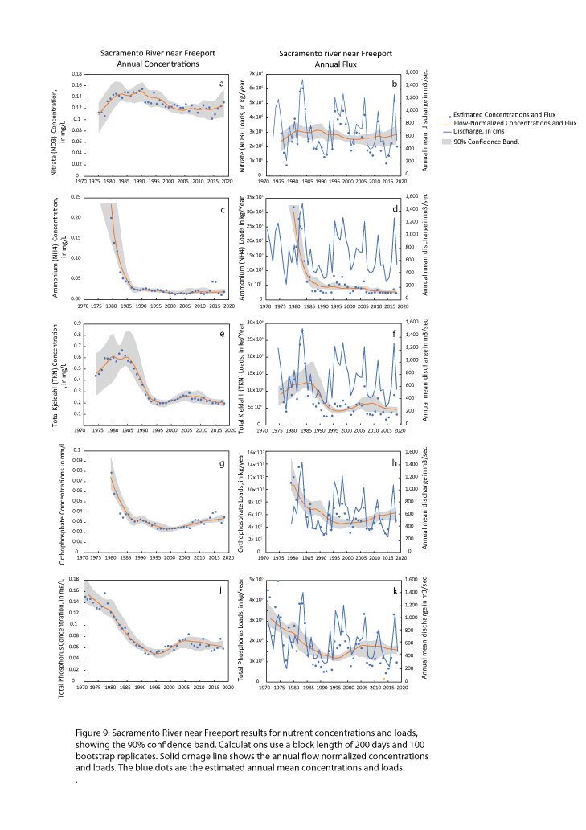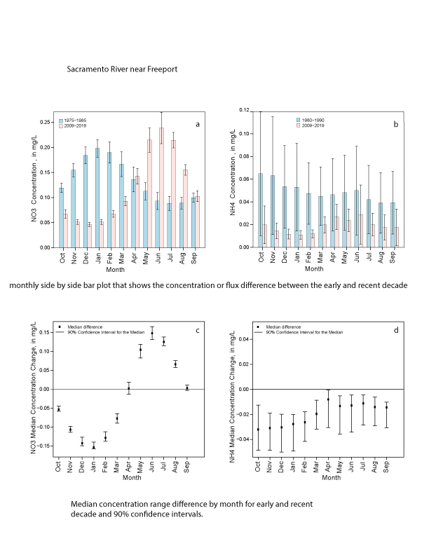

## ***San Joaquin River near Vernalis, Nutrient Concentrations, Fluxes, and Trends***

WRTDS modeling results for the San Joaquin River near Vernalis are shown in Figure 11. Annually averaged flow-normalized nitrate concentrations varied with in the 1970-2019 period and were greatly affected by high variability in discharge (Figure 11a). Results of the EGRETci test indicated a “likely” decrease in concentration (about 0.14 mg/l) and loads (about 0.27 million kg/year) over the 1970-2019 period (Table 2). Figures 11a and 11b show that the width of the 90% confidence band for the flow normalized concentrations and loads were relatively the same throughout the 1970-2019 period. Results of the Mann-Whitney-Wilcoxon Rank Sum test show that in the early decade nitrate concentrations were highest in the winter. On the other hand, concentrations are highest during the summer in the recent decade (fig 12a). Median concentrations difference between the early and recent decade are only significant in the months of February and July through September (fig 12c).

Estimated annual concentrations and loads for ammonium show a different pattern than that of nitrate (figs 11c and 11d). Results show great variation in concentrations during the early time period 1975-1985 and for loads during 1985-1995 time. The ammonium concentrations decline starting in 1995 and continue to decline for the remainder of the period of record (figure 11c). Variation in estimated loads remain similar throughout the 1970-2019 period (fig 11d).

There is a “highly likely” decrease in both concentration (about 0.11 mg/l) and loads (about 0.26 million kg/Year) over the 1970-2019 period (Table 1). Results from the Mann-Whitney-Wilcoxon Rank Sum test show that ammonium concentrations decrease in the recent. Unlike nitrate; the difference between the early and recent decade in NH4 concentrations are significant for all months of the year, with high ammonium concentrations in winter for the early decade and in summer for the recent decade (fig 12d).

Total Kjeldahl nitrogen concentrations and loads decreased continuously throughout the 1970-2019 period similar to that for ammonium (Fig 11e, and 11f). Results from the EGRETci test also show that there is a “highly likely” decrease in TKN concentrations (about 0.78 mg/l) and a “very likely” decrease in loads (about 2.86 million kg/year) over the 1970-2019 period ((Table 2).

Trends in OP concentrations and loads followed a similar pattern over the 1970-2019 period. Results from the EGRETci test showed a “likely” decline in both concentrations and loads for the 1970-2019 period (about 0.01 mg/l in concentrations and 0.05 million kg/year in loads).

Trends in TP concentration and loads follow a similar pattern to that of OP with a greater variation in TP concentrations in the mid-80s reflected in the wide 90% confidence band (fig 11j).

TP concentrations increased in the early decade to reach its highest value of 0.29 mg/l in 1988 followed by a continuance decrease in concentration though the remainder of the time period. Overall results from the EGRETci test show that there is a “highly likely” decline in TP concentrations about 0.09 mg/L and in loads about 0.16 million kg/year over the 1970-2019 period.

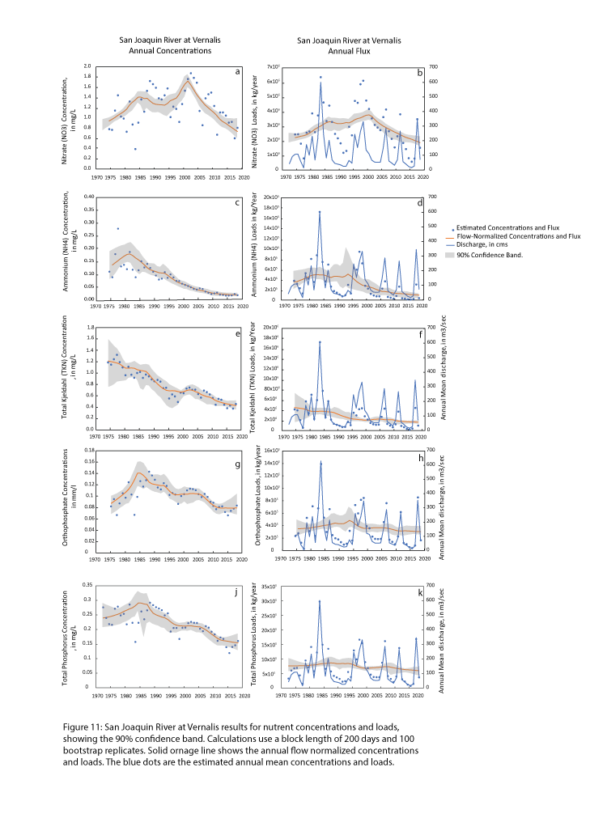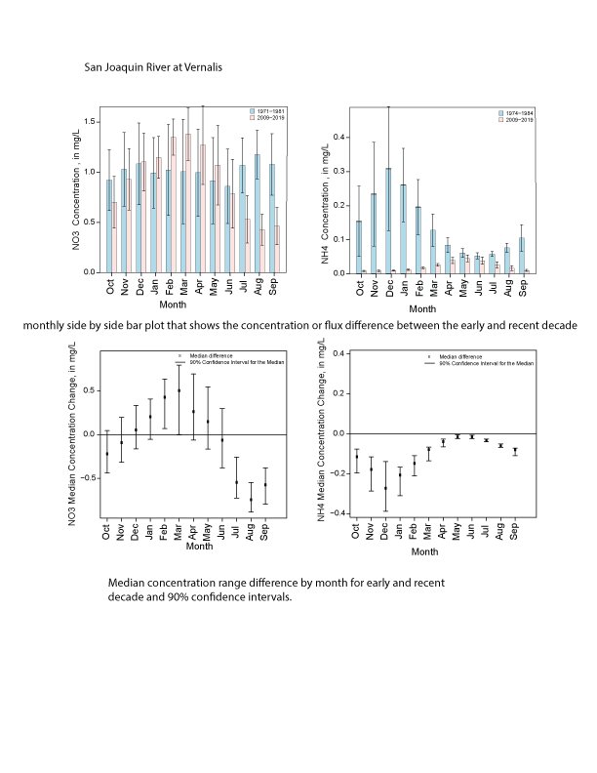

*Nutrient Ratios*

Ratios of nitrate to ammonium have changed over the years at both the Sacramento River at Freeport and San Joaquin River near Vernalis. Time series plots for both locations showing molar concentrations and molar ratios of nitrate to ammonium are shown in Figure xx.

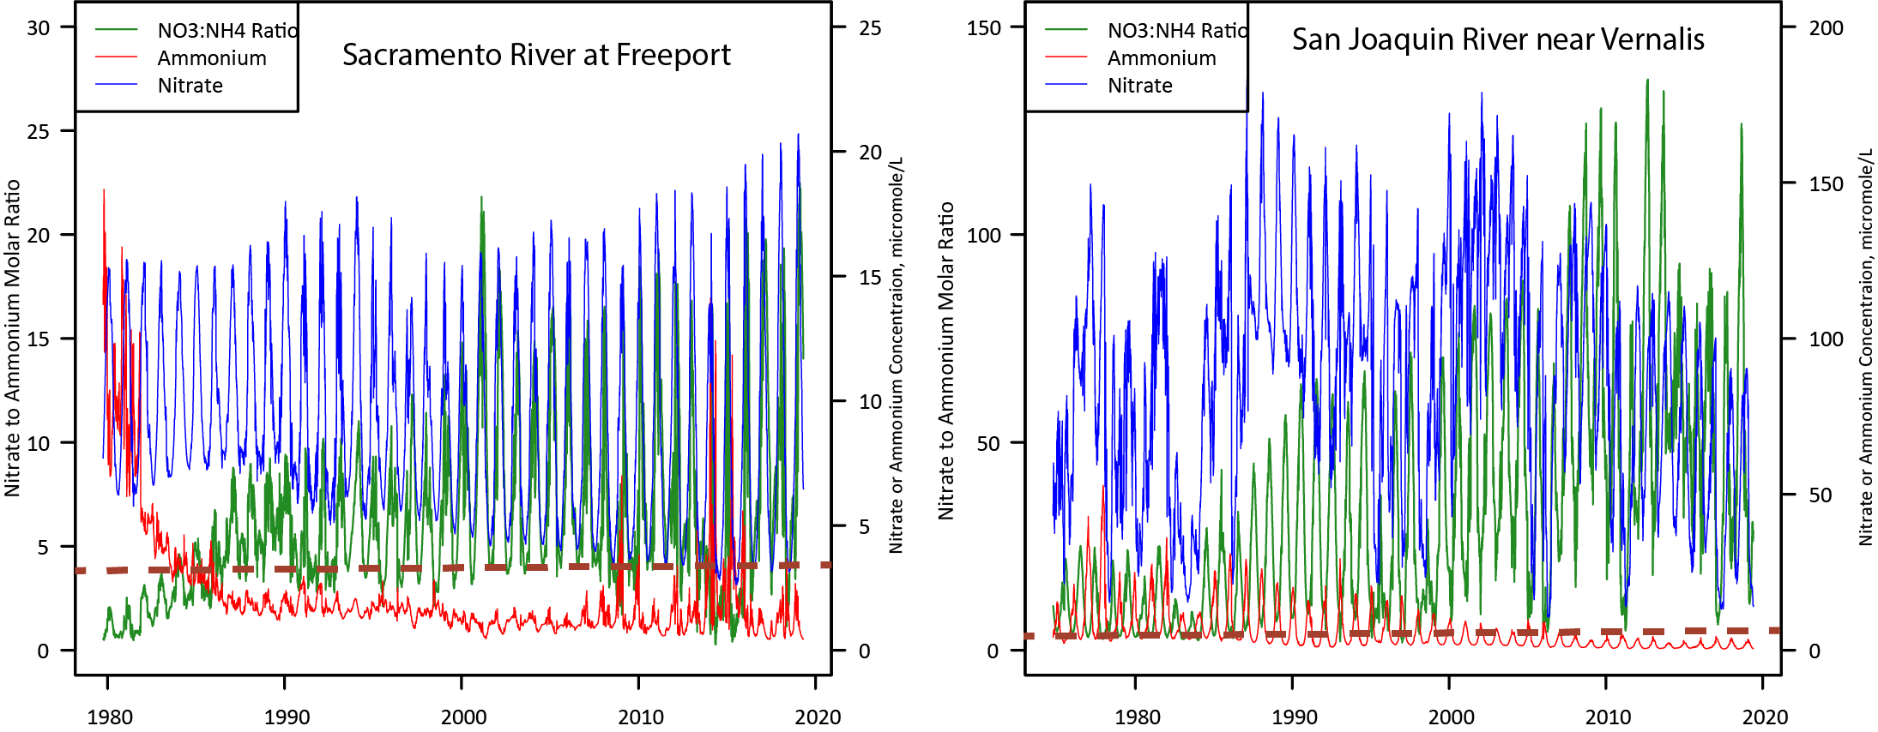

Figure xx. Time series plots of daily modeled nitrate to ammonium ratios and molar concentrations of nitrate and ammonium for the Sacramento River at Freeport and San Joaquin River near Vernalis sites. Dashed red line indicates ammonium concentration of 4 micromoles/L.

Nitrogen ratios differ at these two locations. Both locations show increasing ratios of nitrate to ammonium, and decreasing concentrations of ammonium, for the period of record and the current nitrate to ammonium ratios are much higher at the San Joaquin River at Vernalis due to higher concentrations of nitrate in the water. The median amount of ammonium relative to nitrate at the Sacramento River site was 19% for the period of record, but current amounts (2019) are between 6 to 7 %. In contrast the current relative amount of ammonium to nitrate (2019) in the San Joaquin River is between 3 to 4%.

Concentrations of ammonium above 4 mmol/L may cause adverse affects to primary productivity in the Bay-Delta (Parker et al., 2012). On Figure xx, the location of that concentration is shown relative to daily modeled locations. In the Sacramento River at Freeport, concentrations were generally below that level from 1985 to present except for the drought years of 2014 and 2015 when reverse flow of tidally driven water brought wastewater effluent up to the the sampling location at Freeport. Currently, ammonium concentrations are below 4 mol/L at the San Joaquin River near Vernalis location.

Ratios of bioavailable nutrients have long been suggested as determining which nutrient limits primary productivity in aquatic ecosystems (Redfield, 1958). For marine ecosystems, it was suggested that an optimum ratio of bioavailable nitrogen to phosphorus in water is 16 moles of dissolved inorganic N to one mole of dissolved inorganic phosphorus (Refield, 1958). Water with a ratio of less than 16 to one are thought to be nitrogen limited, while water with a higher ratio are thought to be phosphorus limited. This was based on the nutrient stoichiometry of marine phytoplankton. Although this ratio may be appropriate to determine nutrient limitation in marine aquatic ecosystems, it has been suggested that freshwater systems have a higher ratio of 24:1 (Maranger et al., 2011). As the wastewater treatment plant upgrades come online, the ratio of bioavailable nutrients in the Delta will change because of the drop in ammonium and nitrate loads. The ratios determined just upstream in the Sacramento River at Freeport site provide a good indication of what to expect. Molar ratios of daily inorganic nitrogen (ammonium plus nitrate) to orthophosphate are shown in figure xx. The ratios differ at the Sacramento River and San Joaquin River sites. Nitrate, in particular, is much higher in the San Joaquin River relative to the Sacramento. The plots show an annual cycle of ratios which are better seen as monthly boxplots in figure xx. The Sacramento River at Freeport site has a molar ratio that is mostly less than the ratio of 24:1 suggested by Maranger et al., 2011 and drops below 10 during the growing season indicating a nitrogen limited water entering the Delta. In contrast, the San Joaquin River has generally higher molar ratios of nitrogen to phosphorus with more variability, indicating a general condition of phosphorus limitation, with ratios that increase during the growing season, possibly due to runoff of nitrate rich water from the agricultural San Joaquin Valley. Since much of the San Joaquin River flow is diverted to the export pumps in the southern portion of the valley, the Sacramento River location is more indicative of the nutrient ratios that will happen once the treatment plant upgrades are in place.

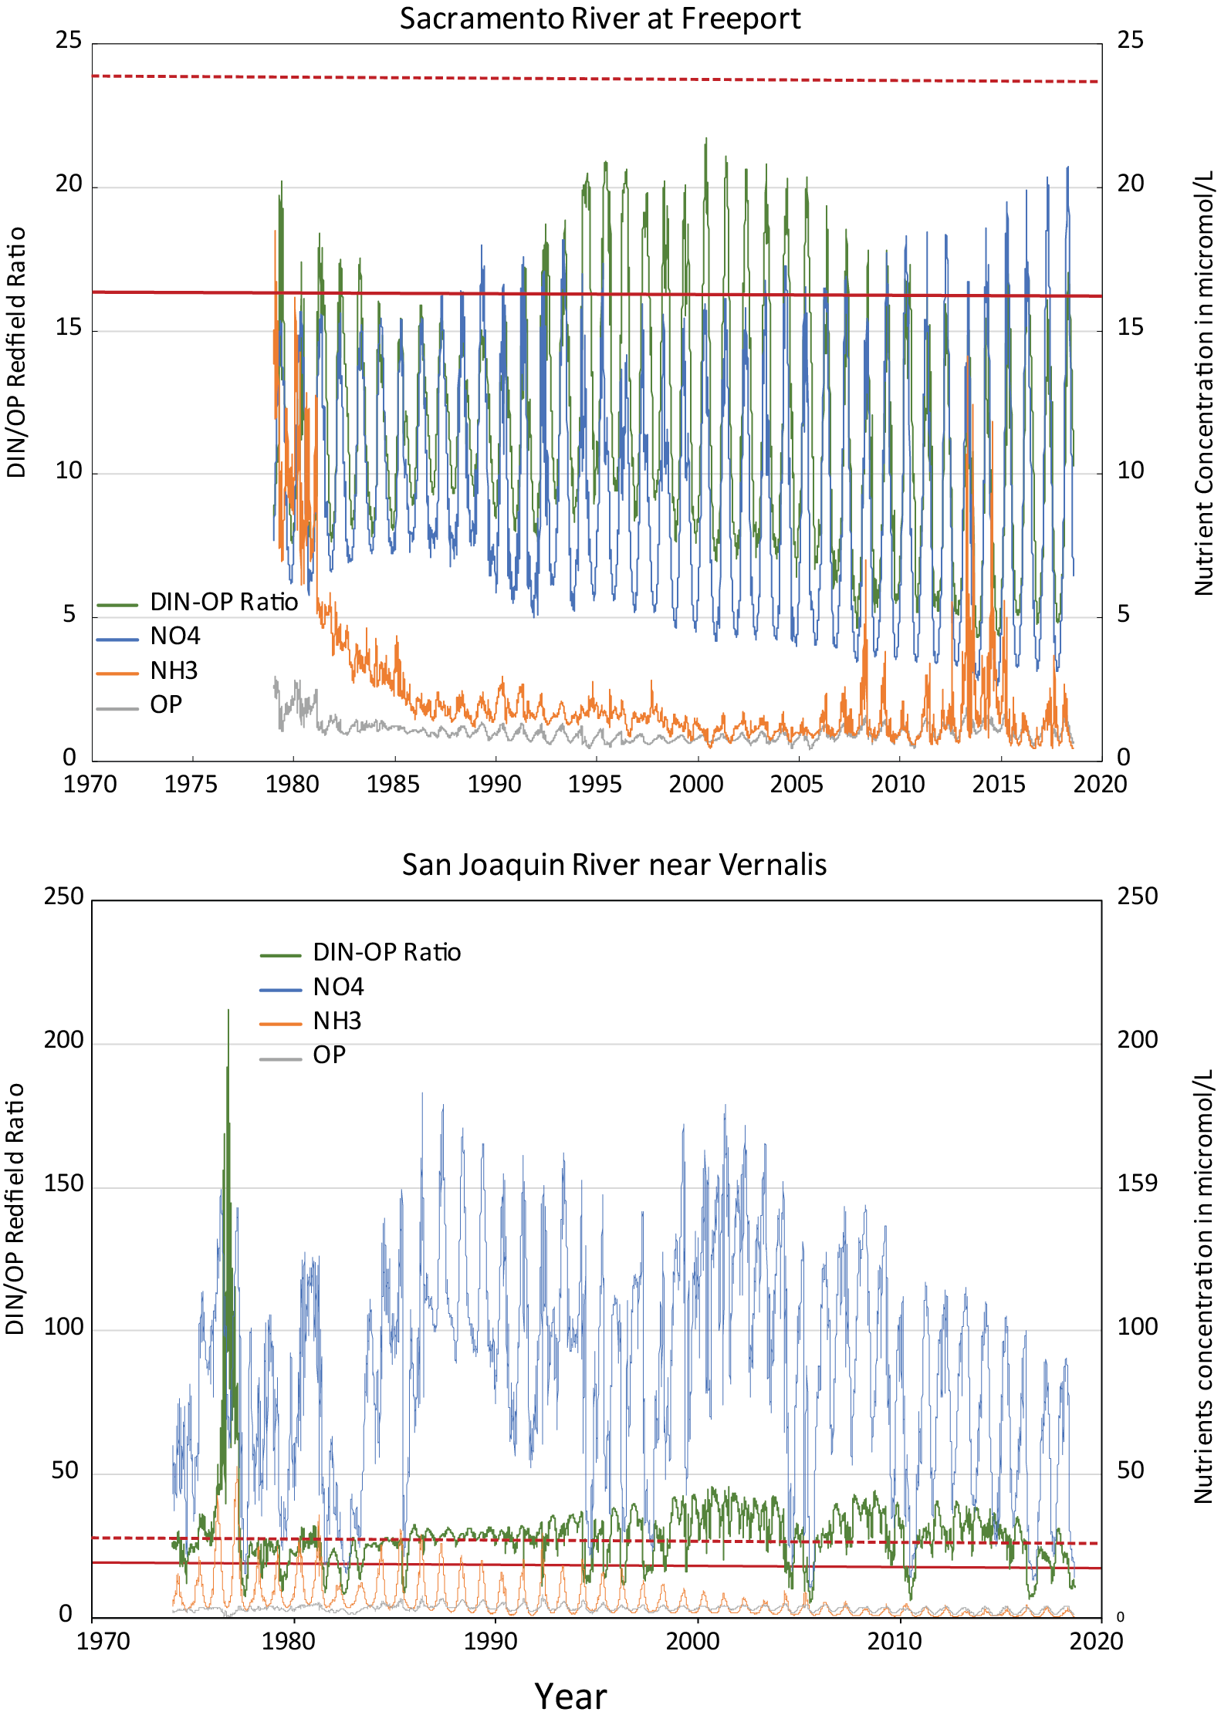

Figure xx. Modeled daily molar ratios of dissolved inorganic nitrogen (nitrate plus ammonium) to inorganic phosphorus (orthophosphate) for the Sacramento River at Freeport and San Joaquin River near Vernalis sites, and modeled daily concentrations of nitrate (NO3), ammonium (NH4), and orthophosphate (OP) in micromole/L.

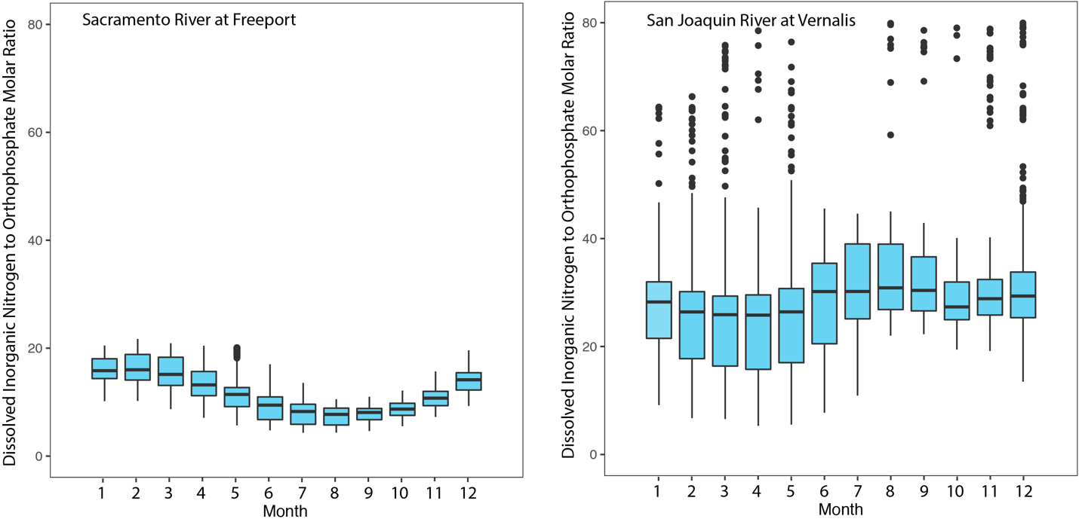

# Figure xx. Boxplots of molar ratios of dissolved inorganic nitrogen to orthophosphate for the Sacramento River at Freeport and San Joaquin River near Vernalis sites.

### Nutrient Sources using SPARROW model

The SPARROW (Wise et. al., 2020) model was used to quantify the amount of total nitrogen and total phosphorus delivered to the Delta and to identify major sources of TN and TP both on a watershed scale and on cumulative scale along the course of the Sacramento River and the San Joaquin River. The model estimated more than 6.8 million kg/year and about 3 million kg/year of total nitrogen is delivered to the Delta from the Sacramento and San Joaquin Rivers respectively. Within the Sacramento River watershed, the model identified major sources of total nitrogen as; 40% from fertilizer and manure applied to agricultural areas within the central valley (fig 5), 32% from atmospheric deposition, 14% from point sources from waste water treatment facilities, 8% from scrub and grass land, and 6% and urban runoff around the main cities (fig 5). Within the San Joaquin River watershed, the model identified major sources of total nitrogen as; 65% from fertilizer and manure, 17% from atmospheric deposition, 10% from point sources from waste water treatment facilities, 5% from scrub and grass land, and 3% and urban runoff (fig 5).

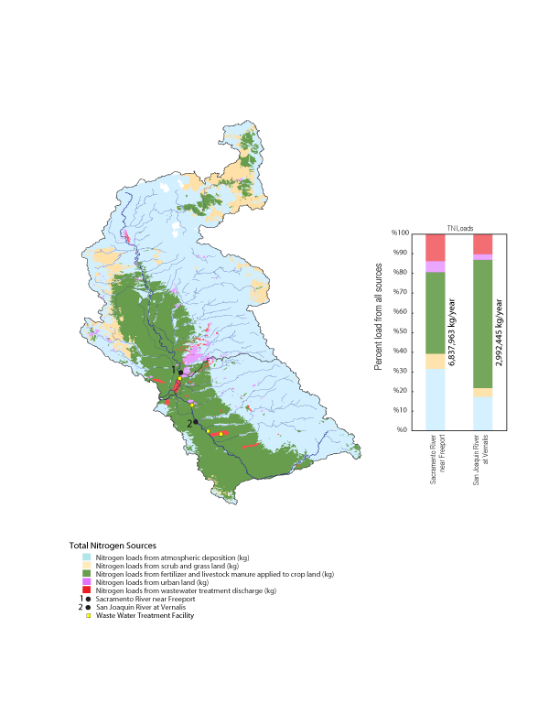

Along the 600 km length of the Sacramento River, sources of TN vary. In the headwaters atmospheric deposition is the main source of TN. As the water moves through the central valley sources change and loads from fertilizer and livestock manure applications increase at about 150 km from the mouth due to increased discharges from the Colusa Basin Drain and the Feather River that deliver water from agricultural land. Downstream of the Sacramento River at Freeport site, TN from point sources increases due to discharges from Sacramento Regional wastewater treatment plant (Fig 6A). In the headwaters of the San Joaquin River, atmospheric deposition is the main source of total nitrogen and then fertilizer and livestock manure applied to agricultural lands is the major source once the river enters the Central Valley. TN loads from point sources increase at about 150 km from the mouth due to increased discharge from waste water treatment facilities in the cities of Turlock and Modesto and increased at about 66 km from the mouth due to discharge from the Stockton waste water treatment plant (fig 6B)

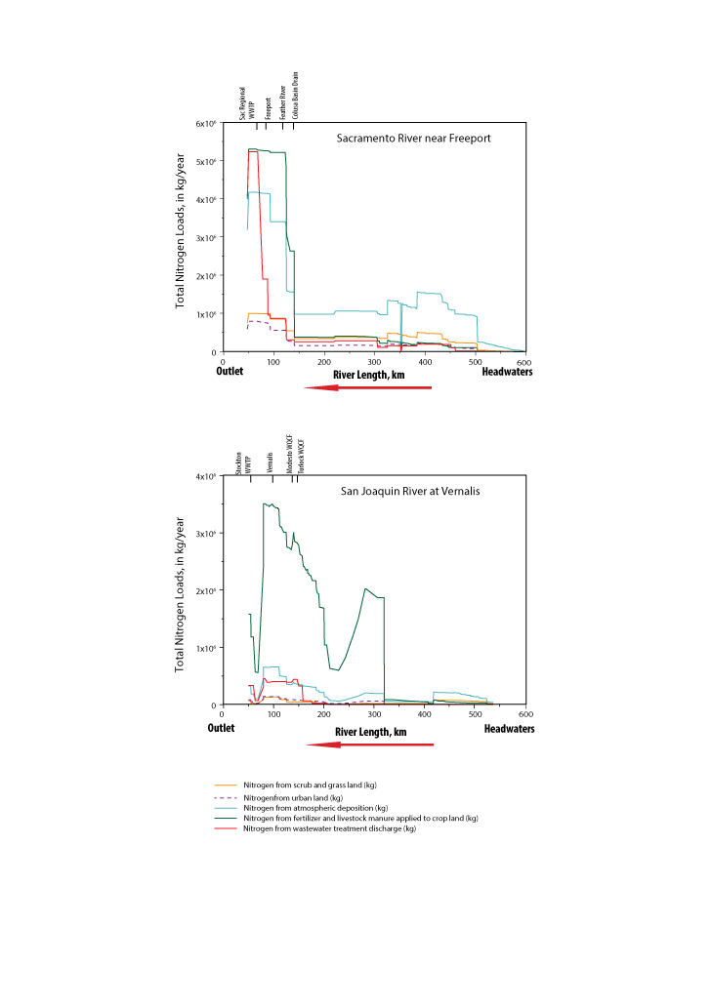

The SPARROW model indicates that 1.5 million kg/year and about 0.5 million kg/year of total phosphorus (TP) is delivered to the Delta from the Sacramento and San Joaquin Rivers respectively. Major sources of TP in the Sacramento River watershed were 46% from agricultural activities (from fertilizer and manure applications to agricultural lands within the Central Valley), 35% from wastewater treatment facilities discharges, 13% from geologic phosphorus from the stream channel and upland areas, and 7% from urban runoff around the main cities (fig 7). In the San Joaquin river watershed, most TP loads (73%) comes from agricultural activities from fertilizer and manure applications, 20% from wastewater treatment facilities discharges, 6% from geologic phosphorus from the stream channel and upland areas, and 2% from urban runoff (fig 7). Along the course of the Sacramento River, agricultural activity (from applied fertilizer and manure) account from most of the TP loads from the headwaters through the central valley till about 70 km from the mouth when discharges from Sac Regional wastewater treatment plan cause a great increase in TP loads from point sources discharges (fig 8A). In the San Joaquin river agricultural activity also account for most of the TP loads along the course of the river. TP loads from point sources start to increase with the increase of discharges from waste water facilities, from Turlock and Modesto at 150 km and Stockton at 66km (fig 8B).

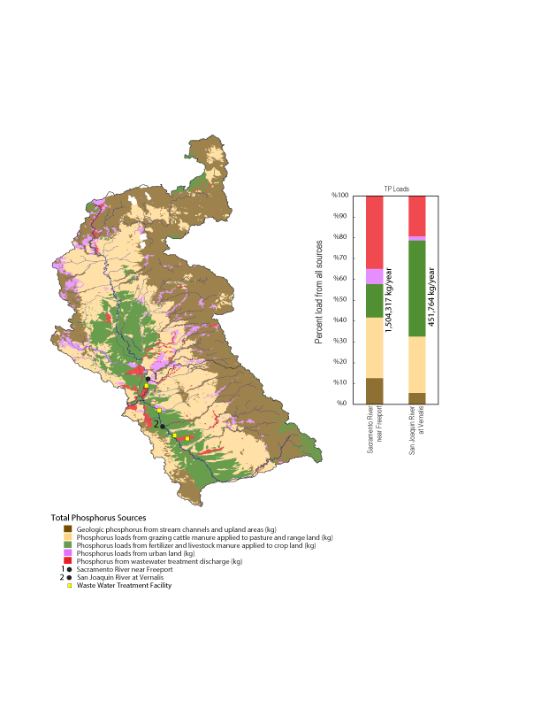

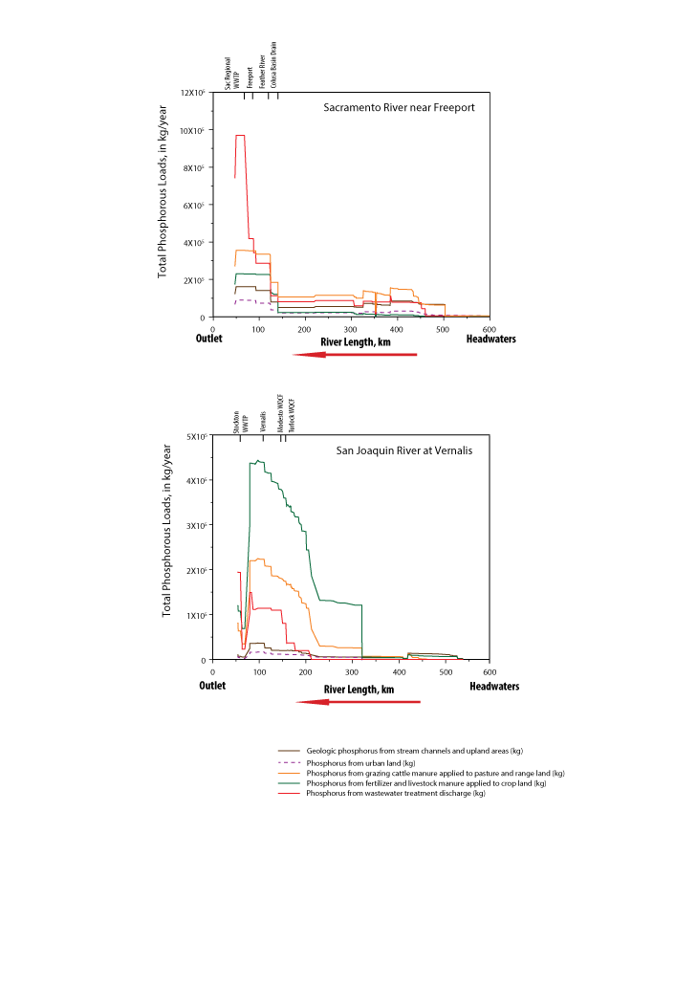

**Comparison of Estimated Loads From Models and Continuous Monitoring**

Models such as WRTDS rely on discrete samples which need to be collected throughout the year and throughout the range of flow conditions. The WRTDS models used here had a sufficient number of discrete samples to produce results with low bias, but it is generally impossible to have a sufficient number of samples to adequately characterize the full range of concentrations over all flow conditions (Pellerin et al., 2014). Water quality sensors can be used to collect data continuously and at high sampling frequency. A nitrate sensor has been used at the Sacramento River at Freeport site since 2013. A comparison plot of nitrate measured by the sensor and the modeled concentrations of nitrate are shown in figure xx. Also shown is a plot of nitrate measured by the sensor and discharge of the Sacramento River at Freeport at 15 minute intervals. It is evident from Figure xx that the EGRET model does not capture the higher concentrations which are mostly associated with runoff events. Discharge and load at this site for the period of time of sensor deployment are shown in Figure xx.

Peak nitrate concentrations generally occur before peak discharge indicating that dilution lowers concentration. The modeled nitrate concentrations from WRTDS match up well with the in-situ sensor measurements, but obviously miss the peaks in concentration. The nitrate sensor had down periods of time so annual load calculations cannot always be made. In particular, the sensor was not recording nitrate during the high flow period in 2017 when discharge was the highest for the period of record. Comparisons of annual load could be made for three years: water years 2014, 2015, and 2016. The WRTDS calculated load for water year 14 was slightly higher than the sensor (873026 kg for WRTDS and 858319 kg for the sensor). The WRTDS estimate of load was lower in water years 2015 and 2016. In 2015, the WRTDS estimate was 1400,923 kg while the sensor estimate was 2,057,506 kg. In 2016, the WRTDS estimate was 2,255,313 kg and the sensor estimate was 2,996,616 kg. The sensor measured loads were between 98 to 146% of the estimated WRTDS loads. The higher loads measured with the sensor are consistent with the fact that discrete sampling cannot always measure the highest concentrations especially with infrequent sampling.

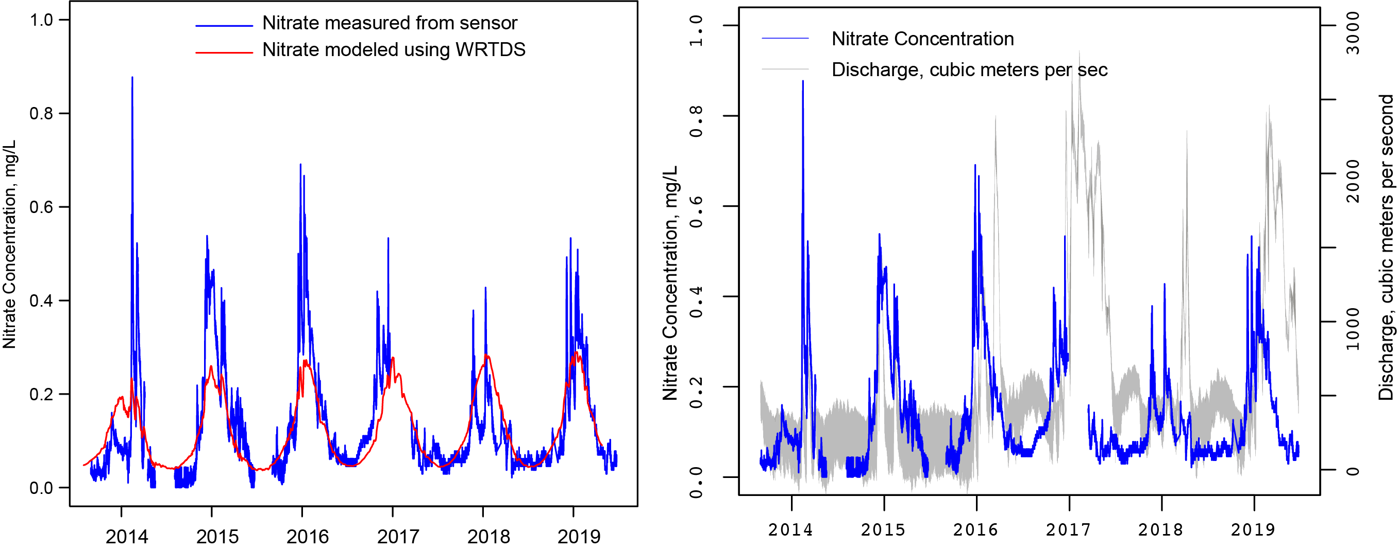

Figure xx. Comparison of nitrate measurements made by the sensor and nitrate concentrations modeled with WRTDS; Nitrate concentration measured by the sensor and continuous 15 minute discharge values.

# **Discussion**

# **References**

Alexander, R.B., R.A. Smith, G.E. Schwarz, E.W. Boyer, J.V. Nolan, and J.W. Brakebill, 2008. Differences in Phosphorus and Nitrogen Delivery to the Gulf of Mexico from the Mississippi River Basin. Journal of Environmental Science and Technology 42(3):822-830.

Beck, M.W., Jabusch, T.W., Trowbridge, P.R., Senn, D.B., 2018, Four decades of water quality change in the upper San Francisco Estuary, Estuarine Coastal and Shelf Science, 212:11-22, https://doi.org/10.1016/j.ecss.2018.06.021.

Domagalski, Joseph and Dina Saleh, 2015. Sources and Transport of Phosphorus to Rivers in California and Adjacent States, U.S., as Determined by SPARROW Modeling. Journal of the American Water Resources Association (JAWRA) 1-24. DOI: 10.1111/1752-1688.12326.

Fishman, M.J., 1993, Methods of Analysis by the U.S. Geological Survey National Water Quality Laboratory, Determination of Inorganic and Organic Constituents in Water and Fluvial Sediments, Open- File Report 93-125; U.S. Geological Survey: Reston, VA, http://pubs.er.usgs.gov/usgspubs/ofr/ofr93125.

Glibert, P.M., (2010): Long-Term Changes in Nutrient Loading and Stoichiometry and Their Relationships with Changes in the Food Web and Dominant Pelagic Fish Species in the San Francisco Estuary, California, Reviews in Fisheries Science, 18:2, 211-232

Hirsch, RM, Archifield, SA, De Cicco LD. 2015. A bootstrap method for estimating uncertainty of water quality trends. Environ Modell Softw 73:148–166 doi:<http://dx.doi.org/10.1016/j.envsoft.2015.07.017>.

Hirsch RM, Moyer DL, Archfield SA. 2010. Weighted regressions on time, discharge, and season (WRTDS), with an application to Chesapeake Bay river inputs: J Am Water Resour Assoc 46:857–880. doi: http://dx.doi.org/10.1111/j.1752-1688.2010.00482.x

Jassby, A.D., J.E. Cloern, and B.E. Cole, 2002. Annual Primary Production: Patterns and Mechanisms of Change in a Nutrient-Rich Tidal Ecosystem. Limnology and Oceanography 47(3):698-712.

Jassby, A.D. and Cloern, J.E. 2000. Organic Matter Sources and Rehabilitation of the Sacramento-San Joaquin Delta (California, USA). Aquatic Conservation: Marine and Freshwater Ecosystems 10:323-352.

Kratzer, C.R., Kent, R.H., Saleh, D.K., Knifong, D.L., Dileanis, P.D., and Orlando, J.L., 2011, Trends in nutrient concentrations, loads, and yields in streams in the Sacramento, San Joaquin, and Santa Ana Basins, California, 1975–2004: U.S. Geological Survey Scientific Investigations Report 2010-5228, 112 pp.

Kraus, T.E.C, O’Donnell, K.O., Downing, B.D., Burau, J.R., Bergamaschi, B.A., 2017, Using Paired In Situ High Frequency Nitrate Measurements to Better Understand Controls on Nitrate Concentrations and Estimate Nitrification Rates in a Wastewater-Impacted River, Water Resources Research, 53, 8423–8442. https://doi.org/10.1002/2017WR020670.

Luoma, S.N., Dahm, C.N., Healy, M, Moore, J.N., 2015 Challenges Facing the Sacramento—San Joaquin Delta: Complex, Chaotic, or Simply Cantakerous, San Francisco Estuary and Watershed Science, vol 13, issue 3, article 7, doi:http://dx.doi.org/10.15447/sfews.2015v13iss3art7

Krich-Brinton, A., 2017. Projected Nutrient Load Reductions to the Sacramento-San Joaquin Delta Associated with Changes at Four POTWs. Larry Walker Associates, Memorandum.

Krich-Brinton, A., J. Sager, M. Trouchon, and R. Warren, 2012. Technical Evaluation of a Variance Policy and Interim Salinity Program for the Central Valley Region. Larry Walker Associates, Memorandum.

Novick, E., R. Holleman, T. Jabusch, J. Sun, P. Trowbridge, D. Senn, M. Guerin, C. Kendall, M. Young, and S. Peek, 2015, Characterizing and Quantifying Nutrient Sources, Sinks and Transformations in the Delta: Synthesis, Modeling and Recommendations for Monitoring, December 2015, San Francisco Estuary Institute.

Parker, A.E., Dugdale, R.C., Wilkerson, F.P., 2012, Elevated ammonium concentrations from wastewater discharge depress primary productivity in the Sacramento River and the Northern San Francisco Estuary, Marine Pollution Bulletin, 64: 574-586.

Pellerin, B.A., Bergamaschi, B.A., Gilliom, R.J., Crawford, C.G., Saraceno, J., Paul Frederick, C., Downing, B.D., Murphy, J.C., 2014, Mississippi River Nitrate Loads from High Frequency Sensor Measurements and Regression-Based Load Estimation, Environmental Science and Technology, 48:12612-12619, doi.org/10.1021/es504029c.

Redfield, A.C., 1958, The Biological Control of Chemical Factors in the Environment, American Science, 46:205-221.

Richey, A., Robinson, A., Senn, D., 2018, Operation Baseline Science and Monitoring Needs—A memorandum summarizing the outcomes of a stakeholder workshop and surveys. http://sfbaynutrients.sfei.org/sites/default/files/final_regional_san_workshop_memo_10.03.2018.pdf

Preston, S.D., R.B. Alexander, G.E. Schwarz, and C.G. Crawford, 2011a. Factors Affecting Stream Nutrient Loads: A Synthesis of Regional SPARROW Model Results for the Continental United States. Journal of the American Water Resources Association 47(5):891-915, doi: 10.1111 ⁄ j.1752-1688.2011.00577.x.

Preston, S.D., R.B. Alexander, M.D. Woodside, and P.A. Hamilton, 2009. SPARROW MODELING – Enhancing Understanding of the Nation’s Water Quality. U.S. Geological Survey Fact Sheet 2009-3019, 6 pp. http://pubs.usgs.gov/fs/2009/3019/, accessed

Saleh, Dina and Joseph Domagalski, 2015. SPARROW Modeling of Nitrogen Sources and Transport in Rivers and Streams of California and Adjacent States, U.S. Journal of the American Water Resources Association (JAWRA) 1-21. DOI: 10.1111/1752-1688.12325.

Sauer, V. B. and D. P. Turnipseed, 2010. Stage Measurement at Gaging Stations. U.S. Geological Survey Techniques and Methods Book 3, Chap. A7. 45 pp.

Schlegel, B., Domagalski, J.L., 2015, Riverine Nutrient Trends in the Sacramento and San Joaquin Basins, California: A Comparison to State and Regional Water Quality Policies, San Francisco Estuary and Watershed Science, vol. 13, Issue 4, Article 2.

Schwarz, G.E., A.B. Hoos, R.B. Alexander, and R.A. Smith, 2006. The SPARROW Surface Water-Quality Model—Theory, Applications and User Documentation. U.S. Geological Survey Techniques and Methods, book 6, chap. B3, 248 pp. and CD-ROM.

Templin, W.E. and D. E. Cherry, 1997. Drainage-Return, Surface-Water Withdrawal, and Land-Use Data for the Sacramento–San Joaquin Delta, with Emphasis on Twitchell Island, California. U.S. Geological Survey Open-File Report 97-350, 31 pp.

Turnipseed, D. P. and V. B. Sauer, 2010. Discharge Measurements at Gaging Stations. In: U.S. Geological Survey Techniques and Methods book 3, chap. A8. Reston, VA, p. 87.

Western Regional Climate Center <http://www.wrcc.dri.edu/cg-bin/cliMONtpre.pl?ca7630>

Wise et al., 2020, Sparrow model—when available

Yost (West Yost Associates) (2011). Wastewater Control Measures Study.

http://www.waterboards.ca.gov/centralvalley/water_issues/drinking_water_policy/dwp_wastewtr_cntrl_meas_stdy.pdf